Please Notice Before You Execute ROM Upgrade Utility(RUU)

- USB cable is directly connected to the PC (don’t use USB hub).
- Disable the standby and hibernation modes on your PC are suggested.
- You need to close all other applications on your PC.
- You need to connect your device by USB cable and establish a connection with ActiveSync (ActiveSync version must be 4.0 or later).
- Do not interact with your device unless instructed to do so.

RUU Upgrade Principle

- Backup your personal data using ActiveSync (You can ignore it if you don’t care your personal data)
- Perform RUU (Follow instructions on the screen of your PC)
- Restore your personal data using ActiveSync. (Optional)

RUU Step by Step Instruction

Before performing RUU, please backup your personal data using ActiveSync first.

- Welcome Screen
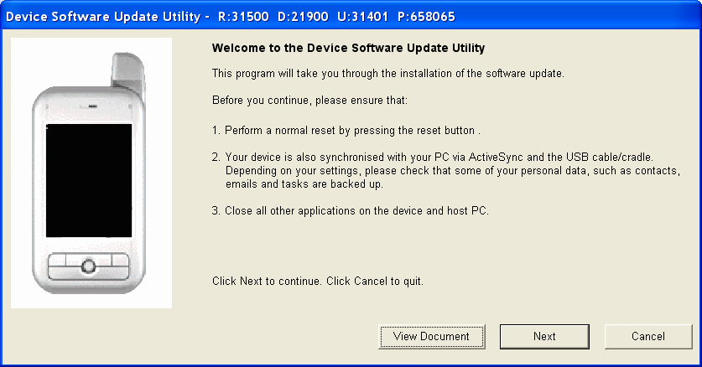
- Press “Next” to begin process.
- Press “View Document” to see this document.

- Verify Screen
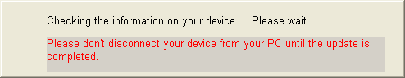

- Compare Device And Image Screen
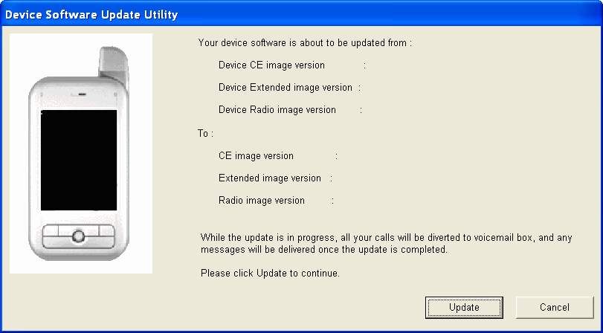

- Upgrade Screen

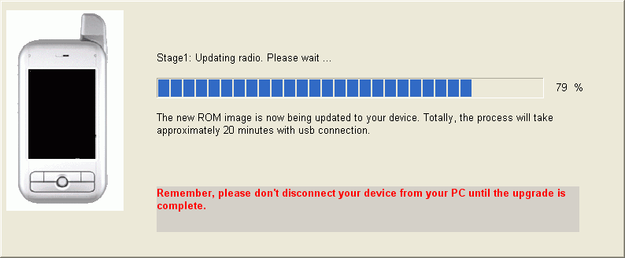

5. Complete Screen

In this stage, you have almost completed the upgrade.
Please follow the instructions to reset your device.

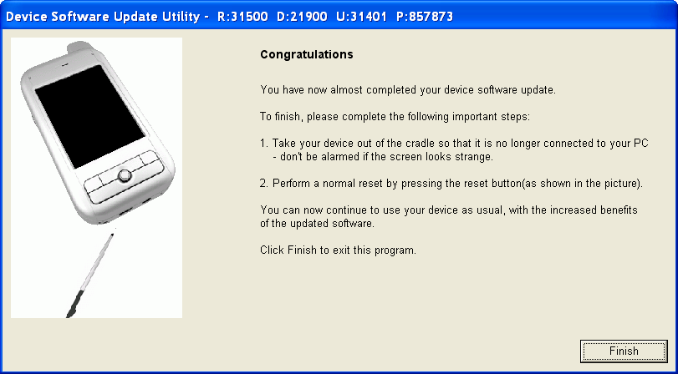

Q & A for RUU Upgrade

Before you calling service center for advance help, please follow the error recovery instructions on the error dialog or refer below Q&A to recovery your question first.

Q1: What should I do before I calling service center?
A: 1.Please make sure the error number (ex: the error number of connection error is 101).
2. Service center may ask you sending error log file (c:\RUU.log) back to service
center.

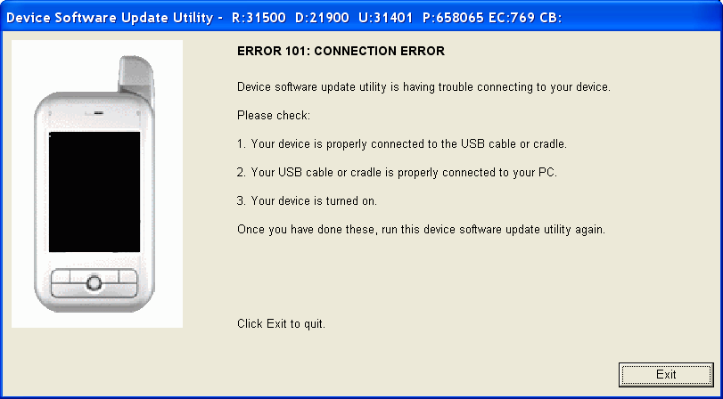

Q2: What should I do if I want using RUU to update my device to new image?

A: 1. Make sure the device name and language type of your device and then download the proper RUU package.
2. Making sure you have installed ActiveSync v4.0 or later.
3. Backup your personal data using ActiveSync (You can ignore it if you don’t care your personal data)
4. During update process, we suggest you don’t execute other program in this host PC (ex: play game, browsing net, watch movie, burning disc…etc). Please close all other program on this host pc as you can. If you can re-start your host PC before running RUU is great, because some program may already occupy system resource and may cause RUU upgrade fail.

Q3: How much time does RUU spend?

A: It depends on what image does RUU need upgrade and your host PC equipment. There are three images may RUU need upgrade.
Stage 1: Upgrade radio image take around 16 ~ 17min with USB connection.
Stage 2: Upgrade extended rom image take around 1 ~ 2 min with USB connection.
Stage 3: Upgrade CE image take around 3 ~ 4 min with USB connection.
Totally, RUU takes around 20 ~ 23 min with USB connection.

Q3: I see the device screen become black and there is a checking dialog on my host PC and over 3 min no any response. What should I do?

A: Some host PC has this issue, it maybe your usb driver has problem at this moment.
Please re-start your host PC and reset your device and then execute RUU again.

Q4: I get “error 100: Model id error”, what should I do?

A: It may due to you get the wrong image. Please check your device’s device name and language type and download proper RUU package from the vender web site again and reset your device and then run RUU again.

Q5: I get “error 101: Connection error”, what should I do?

A: Step 1: Reset your device and connect to a host PC with USB connection again.
Step 2: On the host PC, run ActiveSync and make it connect to your device. The ActiveSync icon on the host PC should be showing green and stopped turning.
Step 2-1: In case the screen of your device goes black, unplug and plug the use cable again. Then, check that the device top screen should display “USB” characters and also the “Windows CE USB devices” should exist in computer management (when you use USB connection and connect device and host pc).
Step3: Rerun the executable update RUU again.

Q6: I get “error 102: CE image file checksum error”, what should I do?
A: Reset your device, re-download RUU package and running RUU again.

Q7: I get “error 103: ROM image file not found”, what should I do?
A: Reset your device, re-download RUU package and running RUU again.

Q8: I get “error 104: Can not open rom image file”, what should I do?
A: Reset your device, re-download RUU package and running RUU again.

Q9: I get “error 112: CE rom update error”, what should I do?

A: Reset your device and running RUU again. If this error still occurs, please re-start your host PC and then run RUU again.

Q10: I get “error 113: Extended rom update error”, what should I do?

A: Reset your device, and running RUU again. If this error still occurs, please re-start your host PC and then re-run RUU again. If this error occurs again and always occurs at 0% upgrade progress, please contact the customer service center.

Q11: I get “error 114: Radio rom update error”, what should I do?

A: Reset your device and run RUU again. If this error still occurs, please re-start your host PC and then run RUU again.

Q12: I get “error 115: Invalid version of ActiveSync”, what should I do?

A: Step1: Download ActiveSync v4.0 or later and then install it.
Step 2: Reset your device and run RUU again.

Q13: I get “error 116: General error”, what should I do?
A: Reset your device and running RUU again. If this error still occurs, please re-start your host PC and then run RUU again.

Q14: I get “error 120: Country id error”, what should I do?

A: It may due to you get the wrong image. Please check your device’s device name and language type and download RUU package from the vender web site again and reset your device and then run RUU again.

Q15: I get “error 122: Extended image file checksum error”, what should I do?
A: Reset your device, re-download RUU package and run RUU again.

Q16: I get “error 123: Radio image file checksum error”, what should I do?
A: Reset your device, re-download RUU package and run RUU again.

Q17: I get “error 201: Get device data error”, what should I do?

A: Step1: Reset your device.
Step 2: Making sure the connection is ok.
Step 3: Running RUU again

Q18: I get “error 202: Read image error”, what should I do?

A: Reset your device and run RUU again. If this error still occurs, reset your device, re-download RUU package and run RUU again.

Q19: I get “Warning 204: Power Quantity is insufficient”, what should I do?

A: Please charge main battery till 50% then execute RUU again.

