**Evo 3D to Boost Mobile Guide**

**DISCLAIMER**

**This guide is provided as general information only; I am not responsible for what you do with it. If you end up with a broken phone and /or suspended account IS YOUR RESPONSIBILITY.**

**…………………………………………………………………………………………………………………………………………………....**

**Files Needed**

* **HTC Diagnostic drivers**
* **CDMA Workshop 2.7+**
* **QPST 2.7 Build 355**
* **QXDM 3.9.19**
* **Boost mobile incognito usb drivers**
* **Boost mobile Rant usb drivers**
* **Win Hex**
* **Windows XP OS (Must have for incognito drivers)**
* **HxD**

**What’s Required**

* **Windows XP (Must have for the Incognito Drivers)**
* **Rooted EVO 3D (Root files in guide) THIS IS OPTIONAL YOU CAN ROOT THE PHONE BEFORE OR AFTER THE PROCEDURE IT DOESN’T MATTER!**
* **CDMA Boost Mobile Phone with 3G- Samsung Incognito or Samsung Rant**

**Downloads**

**FILES NEEDED**[**http://www.4shared.com/file/NmYdNU4D/FASTANDHETVOC.html?**](http://www.4shared.com/file/NmYdNU4D/FASTANDHETVOC.html?) **ROOTING FILES (You will need them in step 5A)**[**http://downloadandroidrom.com/file/HTCEvo3D/rooting/rootevo3d.zip**](http://downloadandroidrom.com/file/HTCEvo3D/rooting/rootevo3d.zip)

**ROOTING FILES (You will need them in step 5B)**

[**http://www.multiupload.com/9SAQPK0A20**](http://www.multiupload.com/9SAQPK0A20)

**Round 1: (Incognito & Rant)**

**Start out by installing all programs and activating you donor phone before you proceed. Now plug you donor phone into your provided usb cable and check the Device Manager for your Phones Com Port Number. Open Cdma Workshop and select the Com port you phone is connected to. Click connect and then Read. You should see your phones information displayed on the left. “If you’re using a rant as a donor phone it will display your SPC so skip round 1 & 2”.Click on the memory tab, under memory/Eeprom put start Address: 0363:0000 leave the size at 65536 bytes, now click read. The Sanyo Incognito sometimes can be very difficult to read the memory, keep trying it will work. You can try to turn off the phone on and off a few times and see if that helps.**

**Round 2: (Incognito)**

**Now install and open up Win Hex, open the memory file you just saved, click on specialist- Gather Text; Recognize text by "6" uncheck everything expect for " Numbers" press "OK", save the file anywhere you like. You should end up with a .txt document with 1 or more 6 digit numbers; one of them is the SPC for your phone, write it or them down.**

**Round 3: (Incognito & Rant)**

**Go back to CDMA Workshop, "Security" tab, SPC - write the 6 digit code from the .txt file inside the box, click on SPC - send. You should get a message saying that the SPC code is correct and the phone is unlocked.”On the Rant just click Read and it will display your SPC and click send and will say phone is unlocked” If you have multiple codes from your incognito, try all of them. Once the phone is unlocked, click on the memory tab. go to NV Items read and save items: 465,466,1192,1194; they must be saved one at a time so for example the First NV Item: 465/ Last NV Item: 465 click OK and save it as 465 then move on to the next item and do the same. Remember to save it somewhere handy, as we will need the later on.” On the Rant Read all nvitems and save the each file. There will be nothing in 1192 or 1194 that’s ok.”**

**Round 4: (Incognito & Rant)**

**Stay in CDMA Workshop, and click the NAM Tab. Click “Read” this will display all your phones information inside of “NAM 1” Save the filename as NAM 1 and do the same for NAM 2.**

**(Pictured below)**

**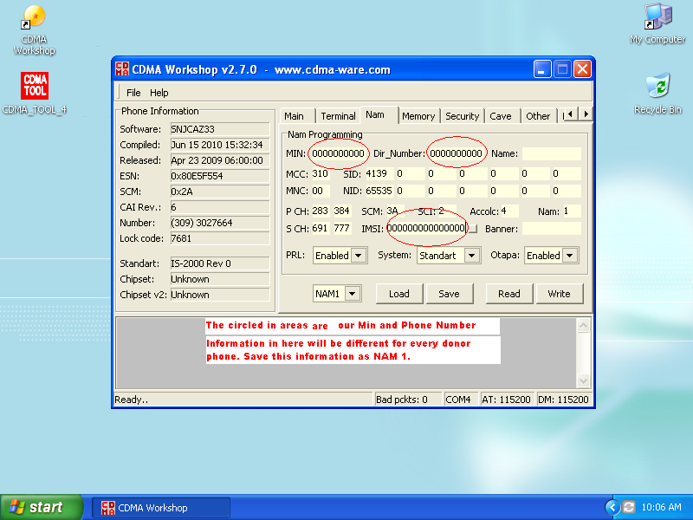**

**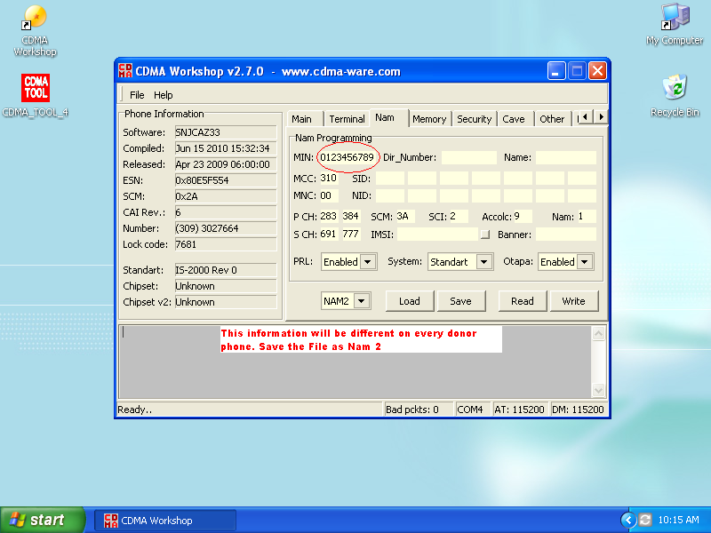**

**Continued……**

**Close Cdma Workshop. Open Service Programming and enter your Donor phones SPC. Click Read and navigate to the “MIP” Tab, we need your Donor phones NAI. Click on Profile 1 and copy down your “NAI” and everything circled in the provided pictures.**

**(Pictured below)**

**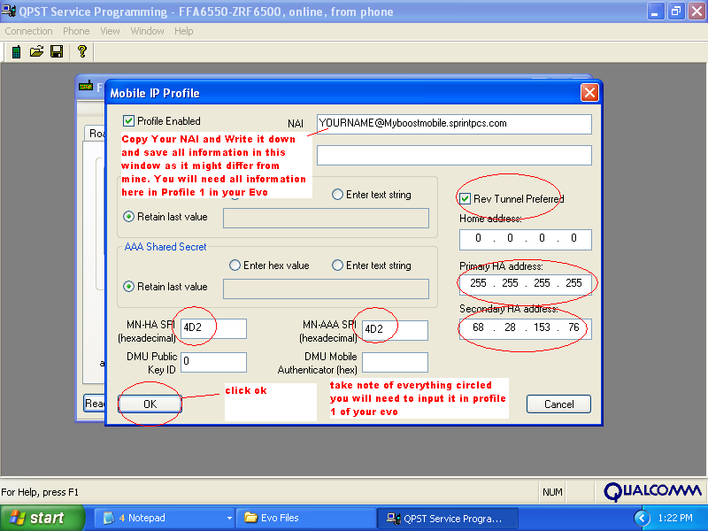**

**Continued…**

**Close Service Programming and open up QXDM. In the command input windows type. Password 01f2030f5f678ff9 hit enter. Requestnvitemread ds\_mip\_ss\_user\_prof . This will find your Ha Shared and AAA Passwords for profile 0.**

**\*Note Rant users this method will work for retrieving the shared password and AAA password, Open up QXDM and enter “ Password” 01f2030f5f678ff9” then First retrieve Profile 0 password by typing “Requestnvitemread ds\_mip\_ss\_user\_prof” retrieve your password by scrolling down to your HA Shared which should be “736563726574” For your AAA Provisioning password open up Nvitem 466 and read your 32 digit password after the “10”, save and return back to Qxdm, Enter “Requestnvitemread ds\_mip\_ss\_user\_prof 1” for Profile 1, once again you HA Shared will be “736563726574” scroll down for your AAA Password. This password will be 6 digits long. Follow the pictures below.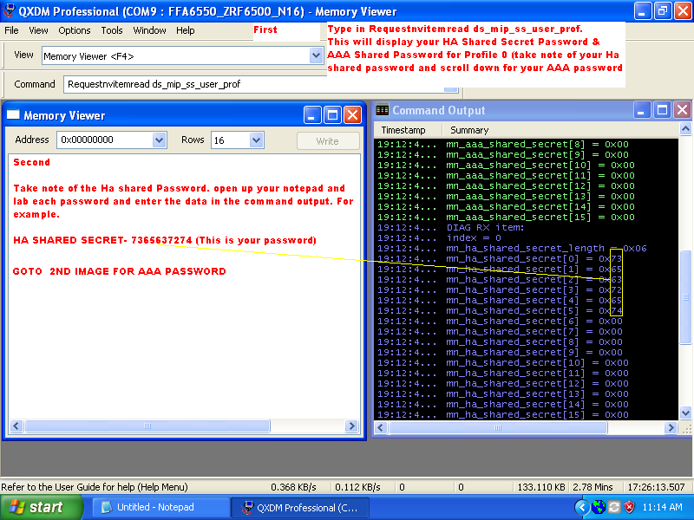**

**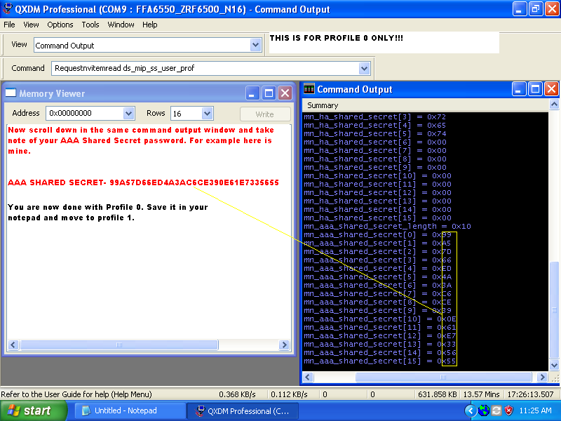**

**Save all information in a notepad and label each Profile and save the passwords for both.**

**This is for Profile 1**

**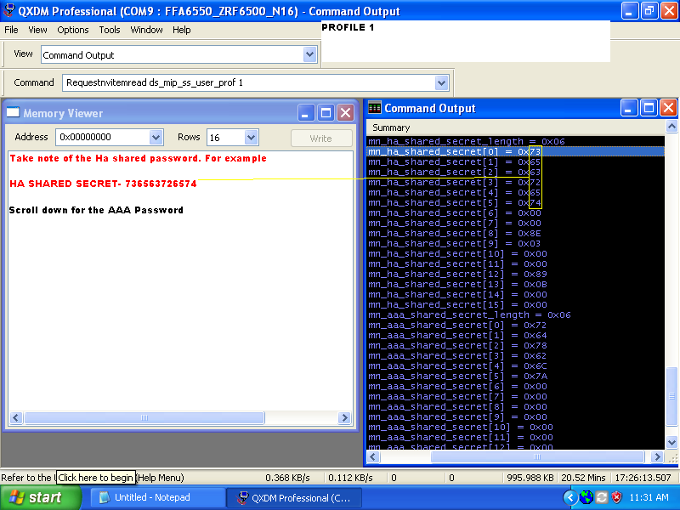**

**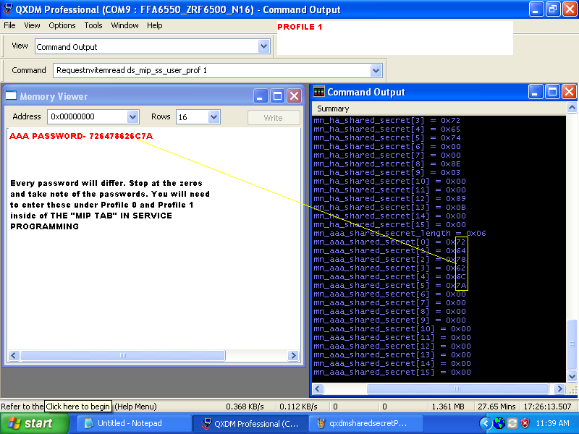**

**You are now done with your donor phone. Turn off or put it on airplane mode, whatever you do don't ever have the phone on at the same time.**

**Round 5A: (EVO 3D)   
Rooting the phone: all the information and steps are on this YouTube video (**[**http://www.youtube.com/watch?v=GmQswv3vKrU**](http://www.youtube.com/watch?v=GmQswv3vKrU)**) or you can keep following the guide with instructions and pictures, your choice.  
  
This guide is for Windows-based computers only.**

**Before we begin, check the software number on your phone by going to Settings->About Phone->Software Information.  
If your software number is 2.08.651.2 or LATER go to round 5B to begin the rooting process if not stay in round 5A.**

**First, connect your Evo 3D to your computer via a micro USB cable and put your phone into USB Debugging mode under Settings->Applications->Development.  
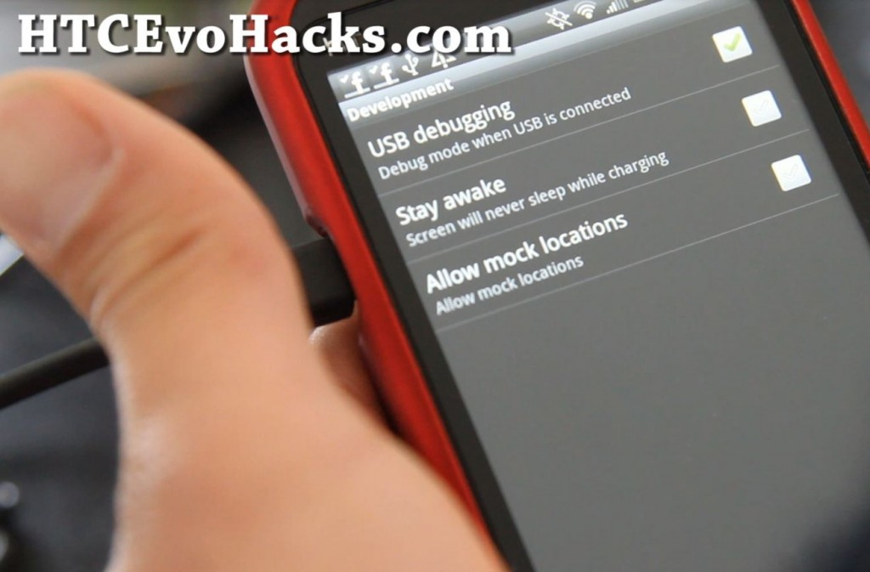  
Next, download the rootevo3d.zip file (which contains everything you need) and unzip it to the root directory of your hard disk such as c:\rootevo3d.  
  
[Download rooting files here](http://downloadandroidrom.com/file/HTCEvo3D/rooting/rootevo3d.zip" \t "_blank)**[**http://downloadandroidrom.com/file/HTCEvo3D/rooting/rootevo3d.zip**](http://downloadandroidrom.com/file/HTCEvo3D/rooting/rootevo3d.zip)

**Install the Evo 3D drivers in this folder by running “HTCDriver3.0.0.007.exe”.  Please install these drivers even if you have installed drivers before otherwise the rooting method will not work!  
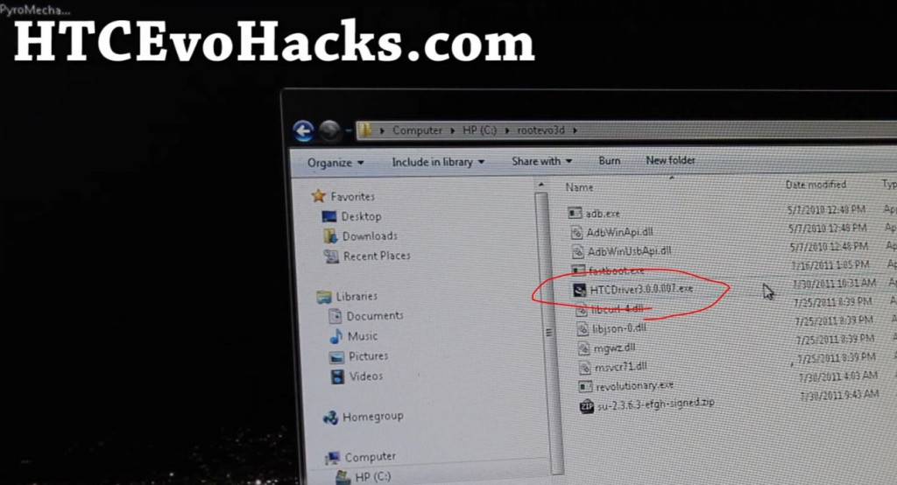**

**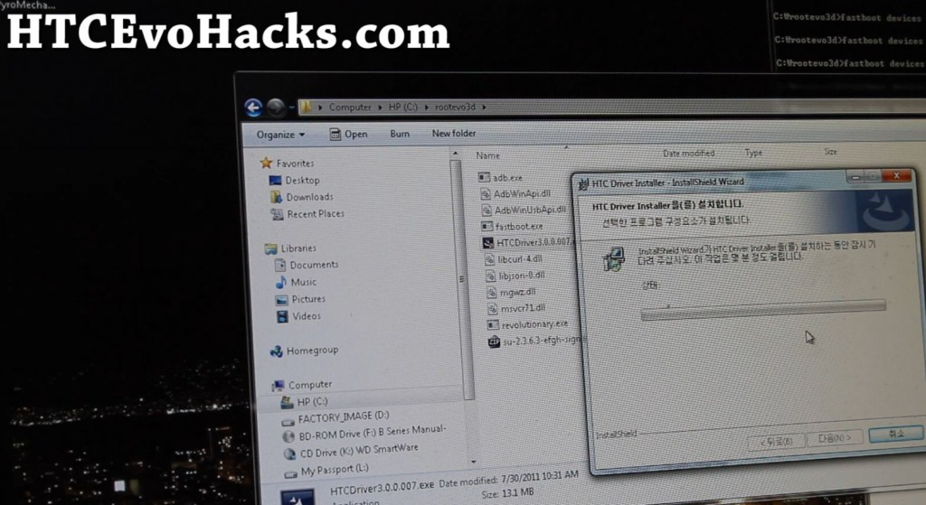**

**When the drivers are installed, you can verify under Device Manager that there’s My HTC under Android USB Devices.**

**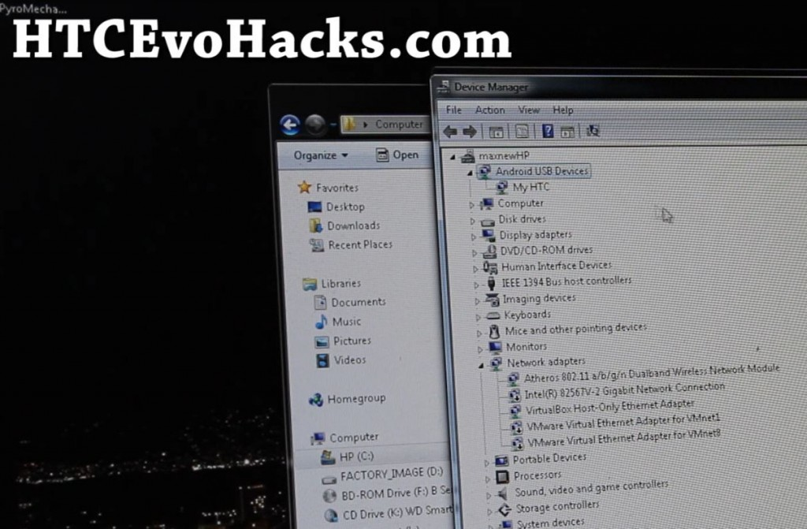**

**Next open up a command prompt by typing “cmd” under Start->Search, then browse to your rootevo3d folder by typing:**

**cd \rootevo 3d**

**Then type:**

**adb devices**

**to find the serial number of your Evo 3D.**

**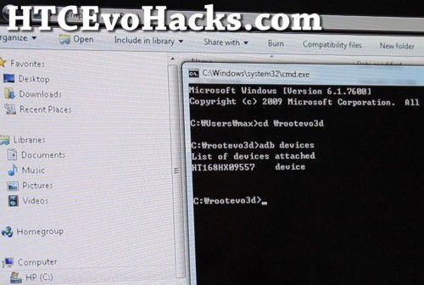**

**If you get something like HT168HX09557, that’s your serial number, write it down on a notepad as we will need it later.**

**If you don’t get this, that means you haven’t installed the drivers correctly or your phone is not in USB Debugging mode. (Also turn off Disk Drive Mode, set it to Just Charge.)**

**Next, we are going to find the HBOOT version number of your Evo 3D.  Take the batteries out then reboot your phone into bootloader mode by holding down both Volume Down and the Power Button.**

**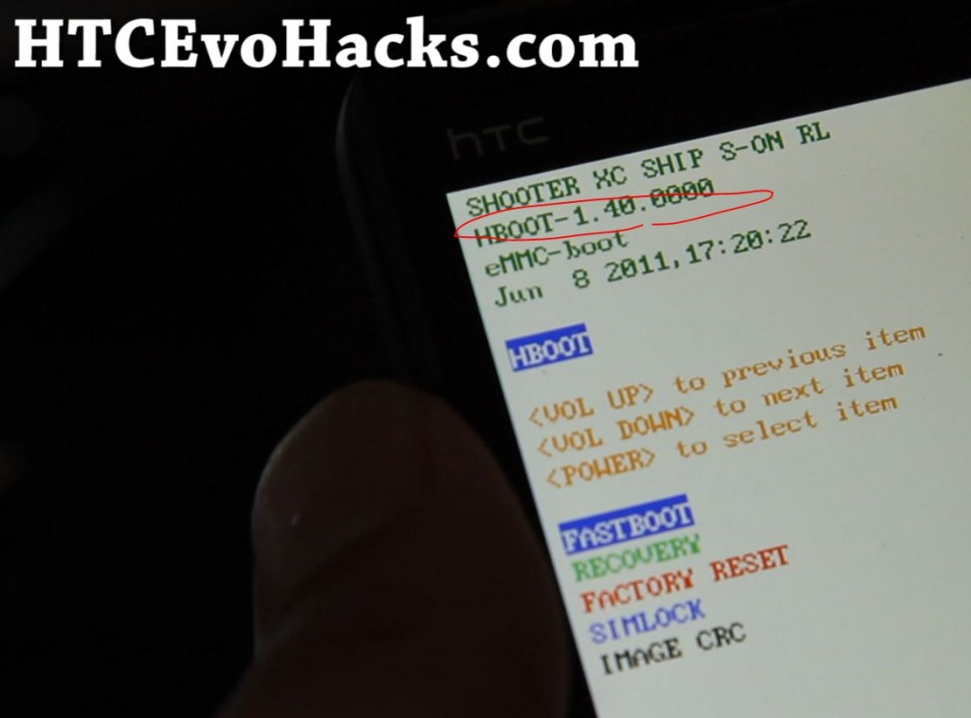**

**Mine says “1.40.0000″, make a note of this as we will need it later and reboot your Evo 3D.**

**Next, goto [this site](http://revolutionary.io/" \t "_blank)**[**http://revolutionary.io/**](http://revolutionary.io/) **and get your beta code by putting in the serial number and choosing the HBOOT.**

**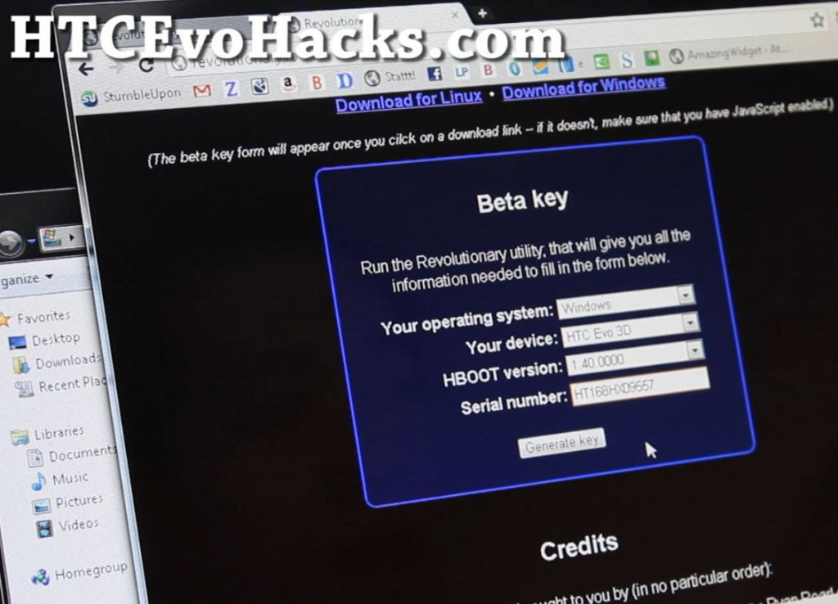**

**Save this beta key/code as we will need to enter it later.**

**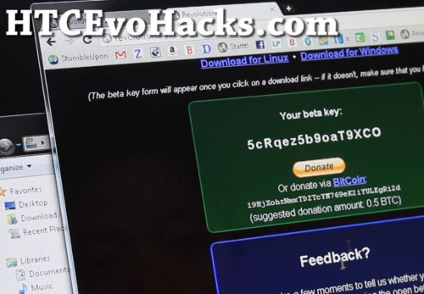**

**Next, go back to the command prompt and type:**

**revolutionary.exe**

**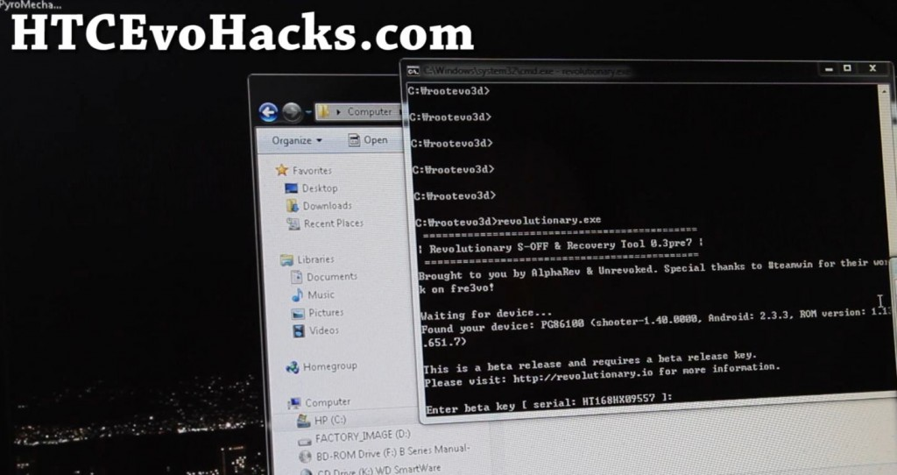**

**Enter your beta key you got earlier here when it asks you and your Evo 3D will start rooting!**

**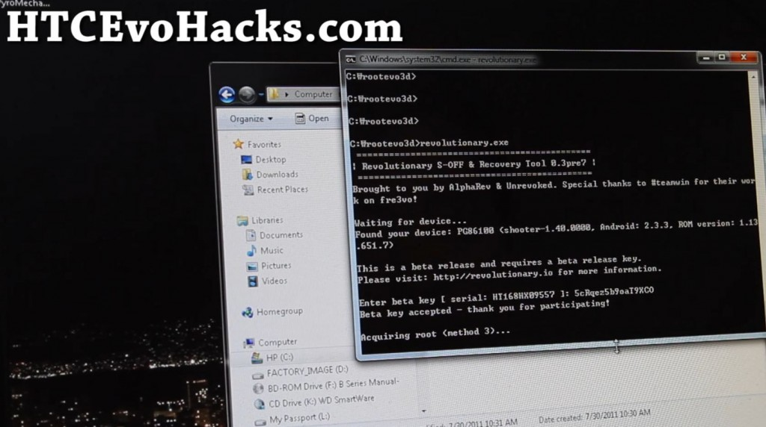**

**It should reboot your Evo 3D a couple times and you will see “S-OFF”!**

**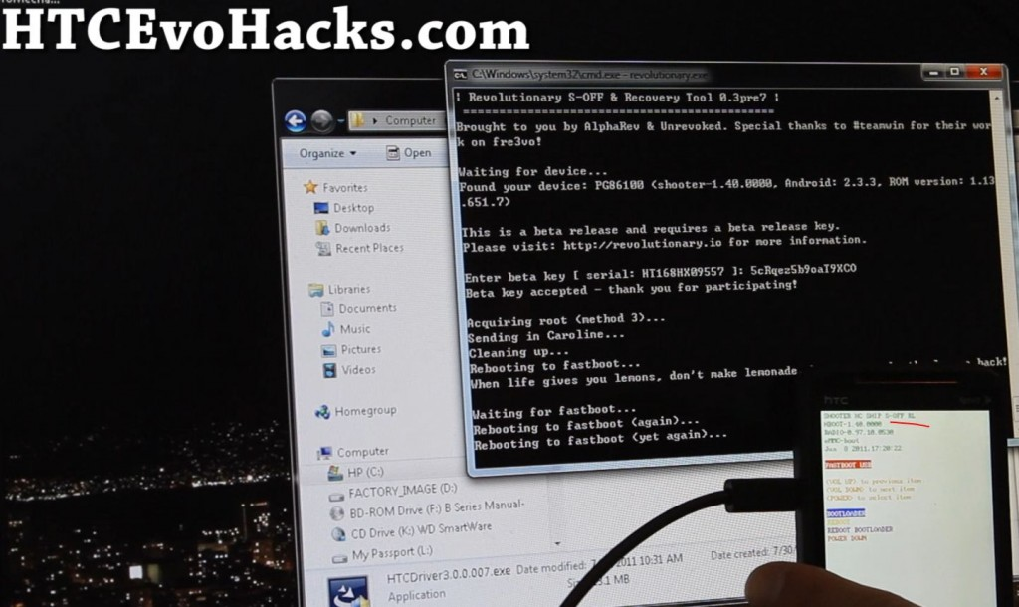**

**When it’s done rooting, it will ask you to download recovery and install it, just hit Y.**

**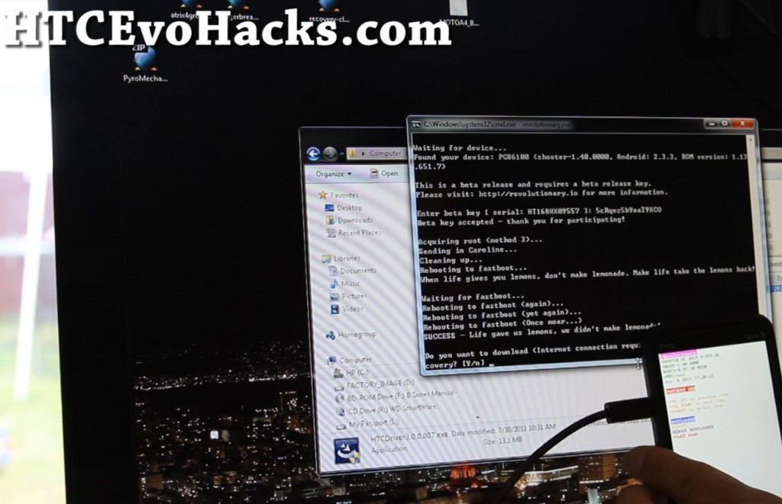**

**If that all went successfully, congrats, your phone’s bootloader is unlocked now and you have ClockworkMod Recovery installed.  The only thing left to do is install SuperUser app.**

**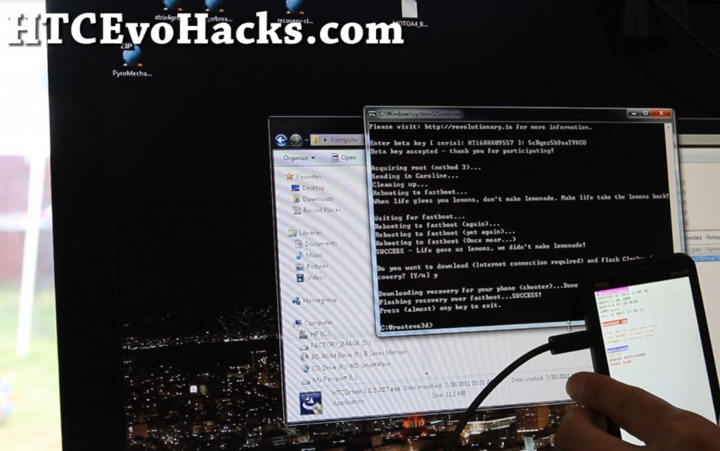**

**Choose “Bootloader” and hit the Power Button.**

**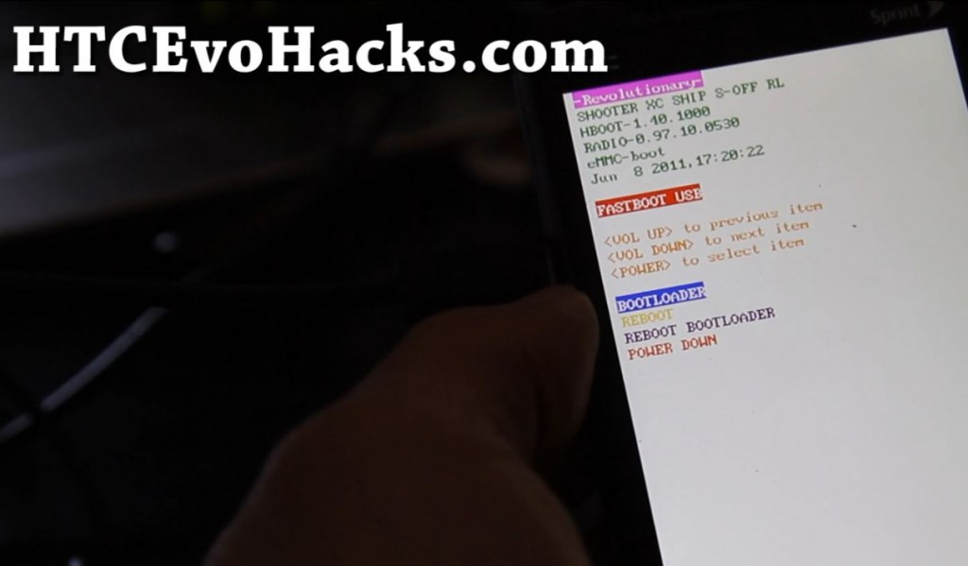**

**Choose “Recovery” and hit the Power Button, this will get you into ClockworkMod Recovery.**

**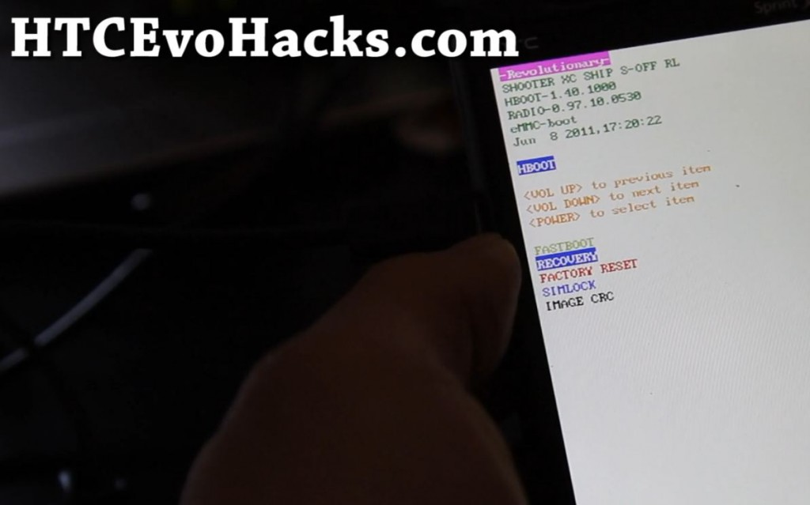**

**Once in ClockworkMod Recovery, choose “mounts and storage” and hit the Power button.**

**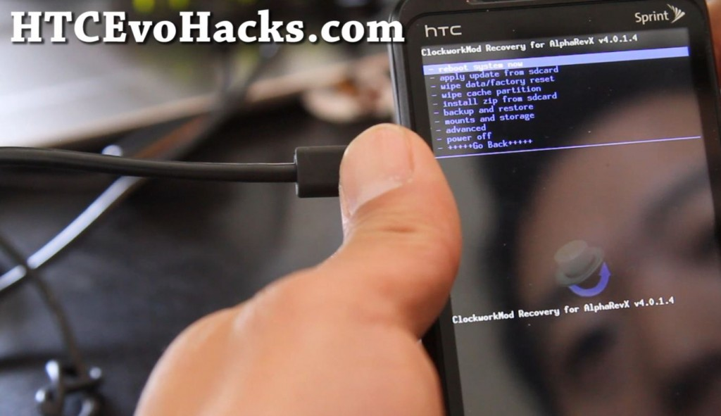**

**Choose “mount USB storage” and hit the Power button.  This will put your Evo 3D into disk drive mode without having you to reboot your phone.**

**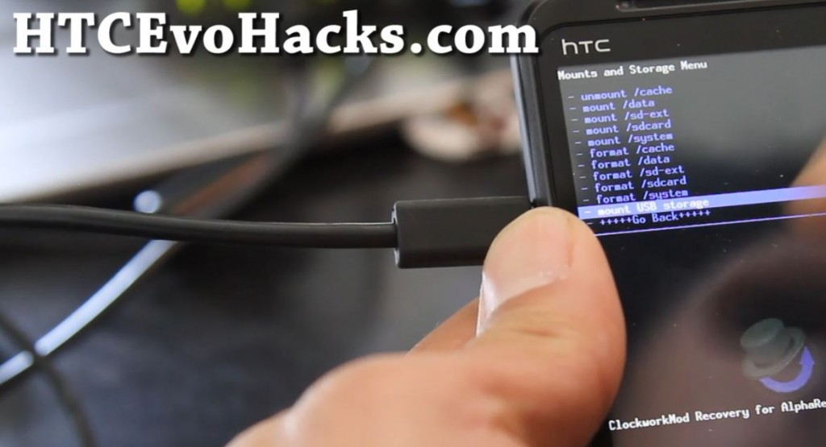**

**Go to your computer and copy over the su-2.3.6.3-efgh-signed.zip file to the SD card of your Evo 3D.**

**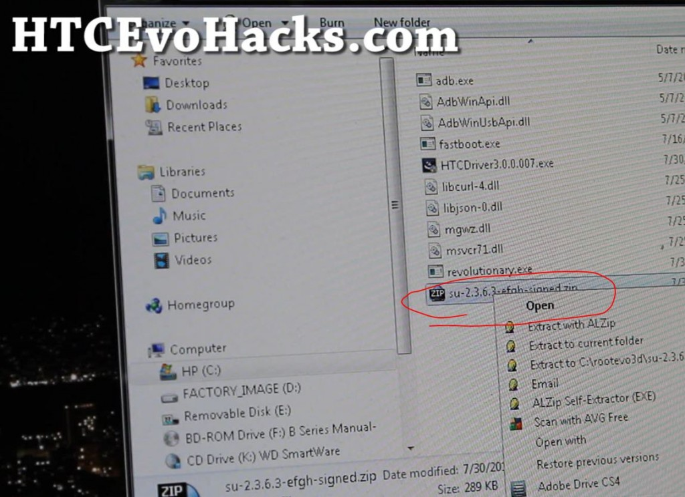**

**Unmount your Evo 3D in ClockworkMod Recovery then choose “install zip from sdcard” from main menu.**

**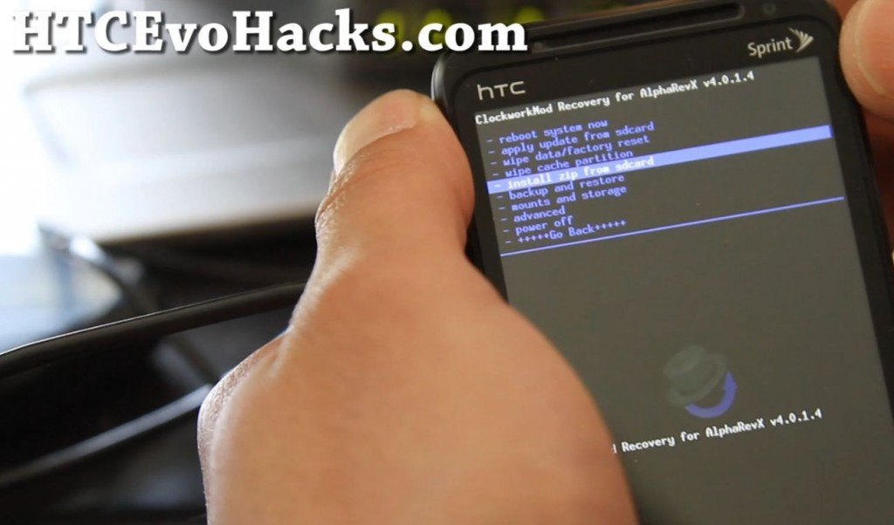**

**Choose “choose zip from sdcard” and hit the Power button.**

**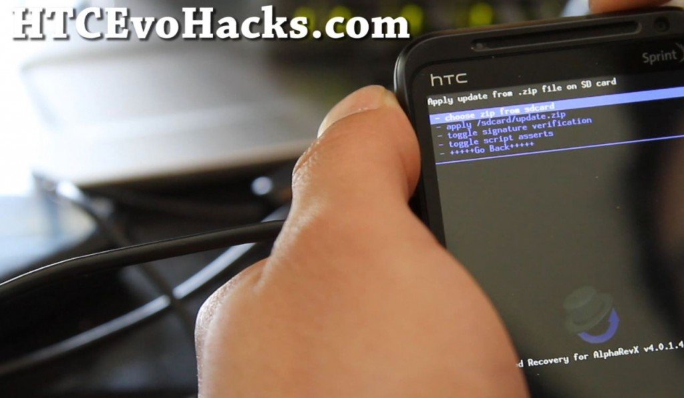**

**Choose “su-2.3.6.3-efgh-signed.zip” and hit the Power button.**

**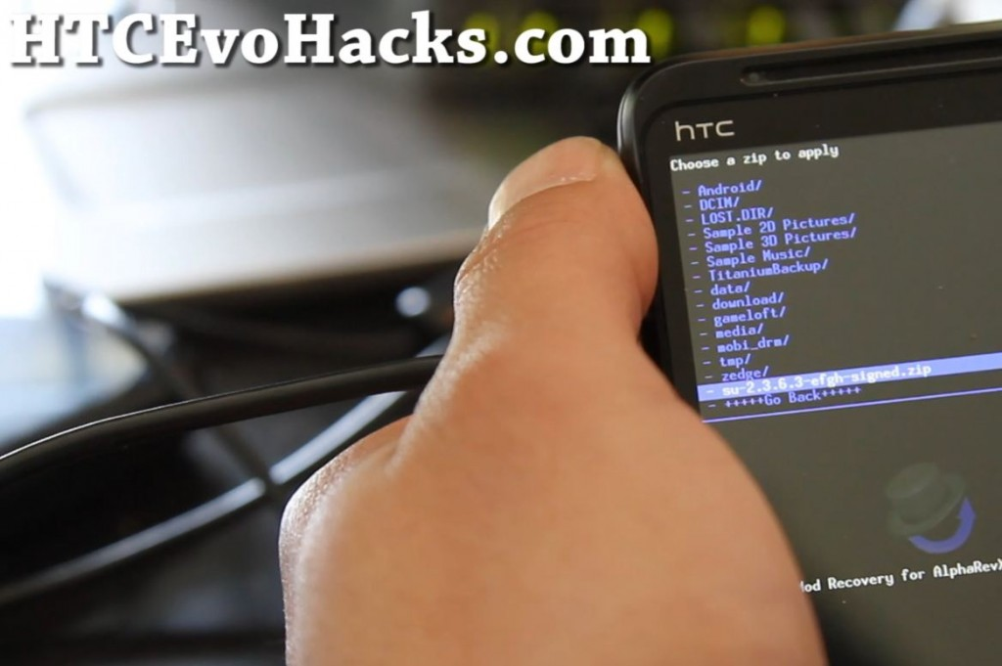**

**It should install the Superuser app.  For those of you who’ve temp-rooted or perma-temp rooted, you might get installation abort error like me but just ignore it as that’s because you already have Superuser app installed.**

**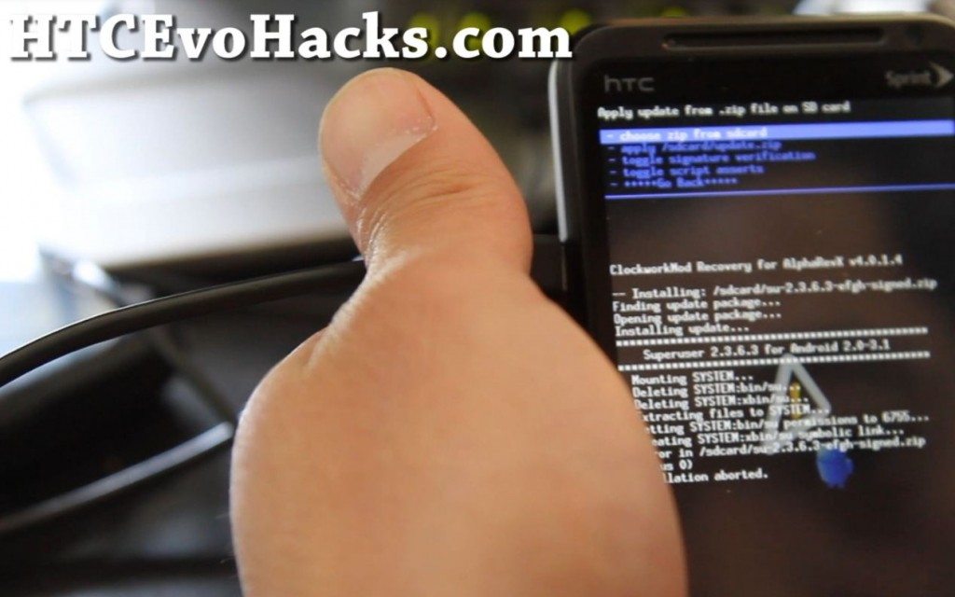**

**Reboot your Evo 3D and it should activate your phone (again).**

**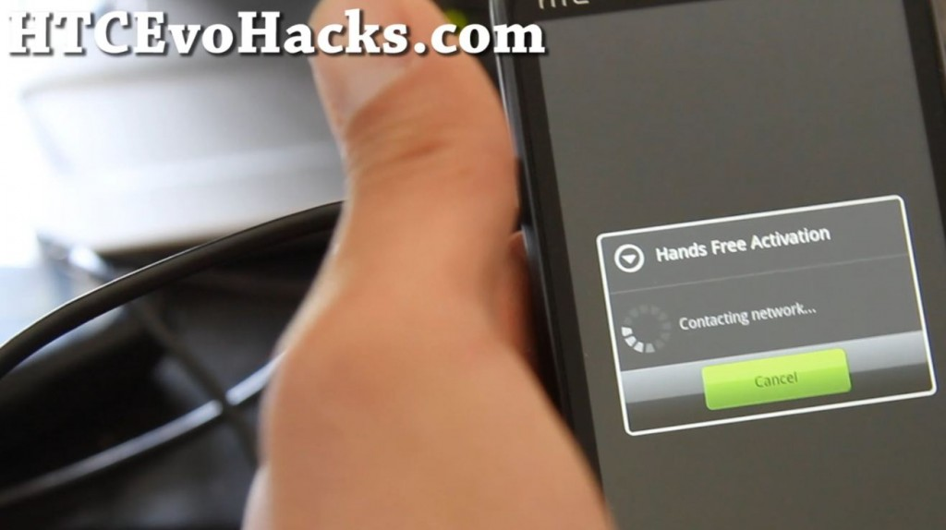**

**When everything comes back up, you should see that Superuser app is installed and you can run rooted apps!**

**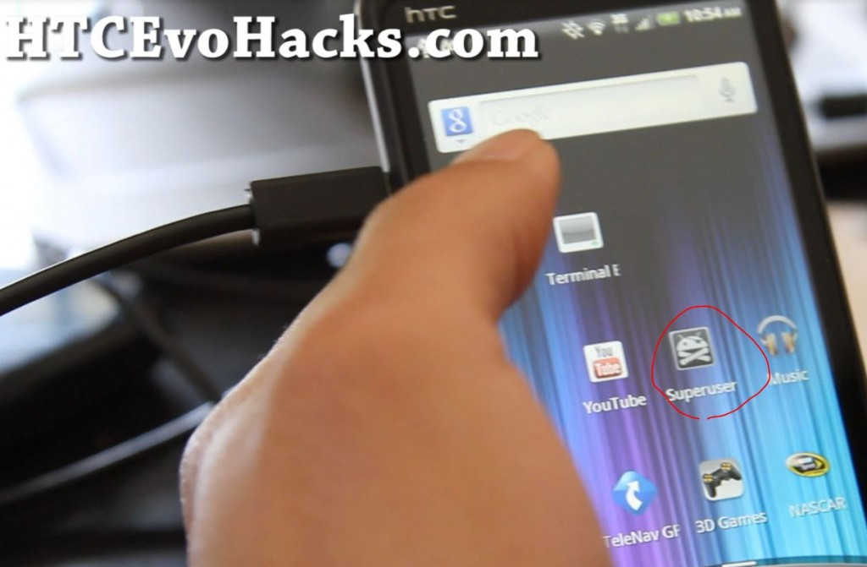**

**If you rooted your Evo 3D, don’t forget to thank the guys over at [Revolutionary.io](http://revolutionary.io/" \t "_blank) who made it all happen!**

**FAQ**

**Installing Recovery failed, what do I do?**

**See [how to install ClockworkMod Recovery manually](http://htcevohacks.com/htc-evo-3d-hacks/how-to-install-clockworkmod-recovery-manually-on-htc-evo-3d/). 🡪** [**http://htcevohacks.com/htc-evo-3d-hacks/how-to-install-clockworkmod-recovery-manually-on-htc-evo-3d/**](http://htcevohacks.com/htc-evo-3d-hacks/how-to-install-clockworkmod-recovery-manually-on-htc-evo-3d/)

**Does rooting erase my apps and contacts?**

**No, this rooting method doesn’t erase any of your apps and contacts, just don’t do factory wipe like some “others” are saying, follow our guide.**

**My camera is not working after rooting!**

**Try rebooting your phone a couple times, sometimes right after rooting, some apps might be a bit buggy but couple reboots will fix it all.**

**What does rooting Evo 3D give me?**

**You can get cool stuff like free wifi tethering, USB tethering, ability to backup/restore ROMs, and also install new ROMs.    Most ROMs also give you easily double-battery life over stock with minimal bloatware so there’s nothing to lose but everything to gain.**

**Can I brick my Evo 3D while rooting?**

**That’s hard to do if you follow all of our directions carefully.  And there’s always a way to unbrick Evo 3D so no, there’s not really a way to brick your phone.**

**Does this method work on Evo 4G or other phones?**

**No, this rooting method is ONLY for Evo 3D, please DO NOT TRY on other phones and that could brick your phone.**

**Round 5B: (EVO 3D)   
Rooting the phone: all the information and steps are on this YouTube video (**[**http://htcevohacks.com/htc-evo-3d-hacks/how-to-root-evo-3d-2-08-651-2-and-later-htc-unlock-method/**](http://htcevohacks.com/htc-evo-3d-hacks/how-to-root-evo-3d-2-08-651-2-and-later-htc-unlock-method/)**) or you can keep following the guide with instructions and pictures, your choice.  
  
This guide is for Windows-based computers only.**

**\*Note – This method of rooting currently doesn’t allow you to flash new kernels (so no overclocking) but you can flash new ROMs. If you haven’t done OTA update to HBOOT 1.50, please follow**[**the method outlined here instead.**](http://htcevohacks.com/htc-evo-3d-hacks/how-to-root-htc-evo-3d/)

**This new rooting method from HTC works on software version 2.08.651.2 and later using HTC’s unlock method.  You can also do it on all platforms including Windows, Linux, and Mac.**

**Before we begin, check the software number on your phone by going to Settings->About Phone->Software Information.**

**Your software number should be 2.08.651.2 or LATER. If not, go do the software update under Settings->System Updates->HTC software update and start over.**

**For Mac users, please replace “fastboot” with “./fastboot-mac” in the instructions below.**

**For Linux users, please replace “fastboot” with “./fastboot-linux” in the instructions below.**

**Step 1. Download rootevo3dnew.zip file and unzip to root folder of your hard disk or desktop.  
  
[Download rootevo3dnew.zip](http://downloadandroidrom.com/file/HTCEvo3D/rooting/rootevo3dnew.zip" \t "_blank)**

**[Mirrors](http://www.multiupload.com/9SAQPK0A20" \t "_blank)  
Step 2. Put your Evo 3D in fastboot mode by first going to Settings->Power and make sure “Fast boot” is checked off.**

**Step 3. Turn off your phone then power up by holding down Power Button and Volume Down button.**

**Step 4. Hit Power again to enter Fastboot.**

**Step 5. Connect your Evo 3D to your computer, your phone should say “Fastboot USB”.**

**Step 6. For Windows, install the HTC drivers HTCDriver3.0.0.007.exe in the zip file.  For Linux and Mac you don’t need to install drivers.**

**Step 7. Open up a command prompt in Windows by typing “cmd” under Start->Search and for Linux and Mac, open up a terminal.**

**Step 8. Go browse into the directory where you unzipped rootevo3dnew.zip, for Windows:**

**cd \rootevo3dnew**

**or**

**cd Desktop\rootevo3dnew**

**if you unzipped to your desktop.**

**For Mac and Linux, likewise:**

**cd /rootevo3dnew**

**or where you unzipped the files to.**

**Step 9. Next type:**

**fastboot oem get\_identifier\_token**

**You should get a bunch of code. If you don’t, you have an older OTA, go do the software update under Settings->System Updates->HTC software update and start over.**

**Step 10. Now, copy everything starting with <<<< Identifier Token Start >>>>  and ending with <<<<< Identifier Token End >>>>> .**

**\*Note – In Windows, when you copy, sometimes it adds a white space to the beginning, if you get errors, try copying the token to Notepad then getting rid of spaces before pasting it to HTC’s site.**

**Step 11. Go to HTCDev.com and sign up as a user.  Then goto Unlock Bootloader->Get Started->Begin Unlock Bootloader.  Agree to the legal terms, proceed all the way to Step 10 and paste the token you just copied.**

**Step 12. If you get errors, try the Notepad tip above, otherwise you should be getting a file called Unlock\_code.bin as an attachment in your e-mail.  
Download this file off your e-mail then copy the file over to the rootevo3dnew directory.**

**Step 13.  Next go back to your command prompt/terminal and type:**

**fastboot flash unlocktoken Unlock\_code.bin**

**Step 14. Go to your phone and hit the Volume Up button and then Power button to unlock bootloader.**

**Step 15. If you got this far, congratulations, your Evo 3D’s bootloader has been unlocked!!!**

**Step 16. Your phone will reboot.**

**Step 17. Put your Evo 3D in fastboot mode by first going to Settings->Power and make sure “Fast boot” is checked off. (Again, yes).**

**Turn off your phone then power up by holding down Power Button and Volume Down button.**

**Hit Power again to enter Fastboot.**

**Step 18. Type the following to install ClockworkMod Recovery:**

**fastboot flash recovery cwm-4.0.1.4-shooter.img**

**Step 19. Go back to your phone and choose Bootloader then hit the Power Button.**

**Then choose Recovery then hit the Power Button.**

**Step 20. When you get Revolutionary CWM blue menus, go to “mounts and storage” using your Volume buttons and hit the Power button.**

**Then choose “mount USB storage” and hit the Power button.**

**Step 21. Go to your computer and copy over su-2.3.6.3-efgh-signed.zip to your Evo 3D.**

**Step 22. Go back to your phone and hit Power button to get out of USB mode.  Then choose “+++++Go Back+++++” and hit the Power button.**

**Then choose “install zip from sdcard” and hit the Power button.**

**Then choose “choose zip from sdcard” and hit the Power button.**

**Then choose  su-2.3.6.3-efgh-signed.zip and hit the Power button.**

**Choose “Yes” and hit the Power button.**

**Step 23. Reboot and enjoy root!**

**FAQ**

**After rooting my Evo 3D using HTC Unlock method, I still get S-ON?**

**It doesn’t matter, the HTC Unlock method gives you a fully unlocked bootloader, the S-ON is meaningless once you unlock as you can install recovery and ROMs.**

**Can you still flash custom kernels?**

**Yes, you can still flash custom kernels but you need to [launch ClockworkMod Recovery from Fastboot](http://htcevohacks.com/htc-evo-3d-hacks/how-to-install-kernelrom-on-a-rooted-hboot-1-50-for-htc-evo-3d-htc-unlock/).   I recommend you use this method for flashing any kind of ROMs too.**

**Need accessories? Get 10% OFF on [HTC Evo 3D Accessories](http://htcevohacks.com/out/evo3dwirelessemporium" \t "_blank) or [HTC Evo 4G Accessories](http://htcevohacks.com/out/evo4gwirelessemporium" \t "_blank) at WirelessEmporium with coupon code CJ10EK at checkout.**

**Round 6:**

**Follow these steps in exact order.**

**1. Download and install the QPST Build 366 of version 2.7 and the HxD, and the latest Android SDK from the following link:** [**http://developer.android.com/sdk/index.html**](http://developer.android.com/sdk/index.html)

**2. Put the phone in USB debugging mode by going to settings/ applications/ development and check in where it says USB debugging, also it is helpful to check stay awake so you can see the phone processes while working.**

**3. Go to phone and dial ##3424# to access Diagnostics mode the computer will need the appropriate drivers to continue, once installed move on to the next step.**

**5. Open your device manager from the control panel, and locate your com ports, expand the com port section and you will see the port for HTC DIAGNOSTICS.**

**6. Open QPST Configuration and add the new port for the HTC, then close configuration.**

**7. Open EFS Explorer from the start menu under QPST and make sure the phone is showing up then, Enter the SPC code and press OK.**

**8. Once the phone reads completely make a new directory named (open sesame door) without the parentheses and all lower case**

**9. After making the new folder locate abd.exe from the android sdk install folder and press: start, run and type cmd then press enter you will get a command prompt window that opens up navigate to the android sdk directory and type; adb reboot, the phone should then reboot if you’ve done as you were supposed to.**

**10. After the phone reboots read it again with QPST EFS Explorer which still should be opened, you will notice that the red no access circle has been removed from the nvm directory so expand it and go to the num directory, locate file 0 and drag it from EFS to your desktop and file 1943 the same way.**

**11. Open HxD and then open up the 0 file on the desktop it should be your ESN. Zero it all out and then save it, do the same for the MEID in 1943.**

**12. Back to EFS and right click in the area and click Copy Item File from PC…, then select the new saved files one at time, it will write the and confirm it.**

**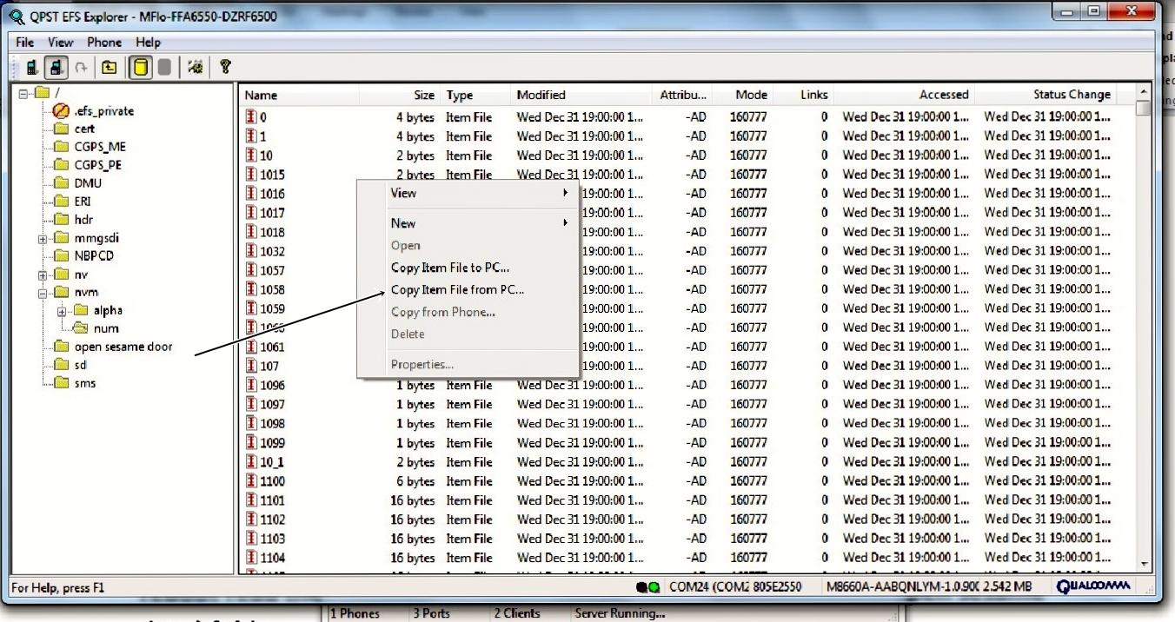**

**13. Go back to the adb command prompt and type adb reboot again, after reboot read the phone once again then with EFS and delete the (open sesame door) folder.**

**14. Reboot the phone one last time with adb reboot in the command prompt, when the phone reboots it’s done, dial ##786# to make sure there all zeros.**

**Round 9 (EVO 3D)**

**After zeroing all MEID and ESN locations, Reboot your Evo and Dial ##786 to make sure the MEID and ESN is all zeros. \*Note if you reboot and your Meid and or ESN is still not zeros then you missed a file somewhere in memory and have to go back to step 6 and rewrite every file again.. This can be a frustrating step and not an easy one by any means but if you keep looking you will find it.**

# Round 10 (EVO 3D)

**Now you can write your MEID/ESN of you Incognito to your Evo 3D, In QXDM type the following commands. (Replace the X’S with your meid**

**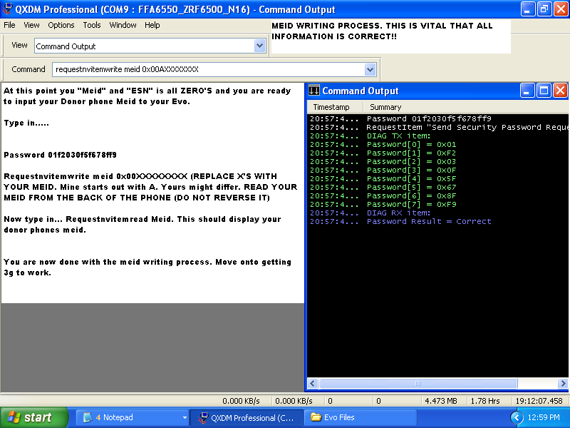**

**Password 01F2030F5F678FF9**

**RequestNVItemRead Meid (this will display the current Meid)**

**RequestNVItemWrite Meid 0x00A0000000000 <-Meid/HEX ID from your donor Incognito/rant**

**RequestNVItemRead Meid (This should now display your new Meid)**

**RequestNVItemRead ESN (This should now display your correct Esn)**

**You are now done close QXDM.**

**Knockout Round: (EVO 3D)**

**Now open QPST Service Programming, select your Evo and press OK. Once connected, Read from Phone and enter you Evo SPC code we got earlier. Navigate to the M.IP tab.**

**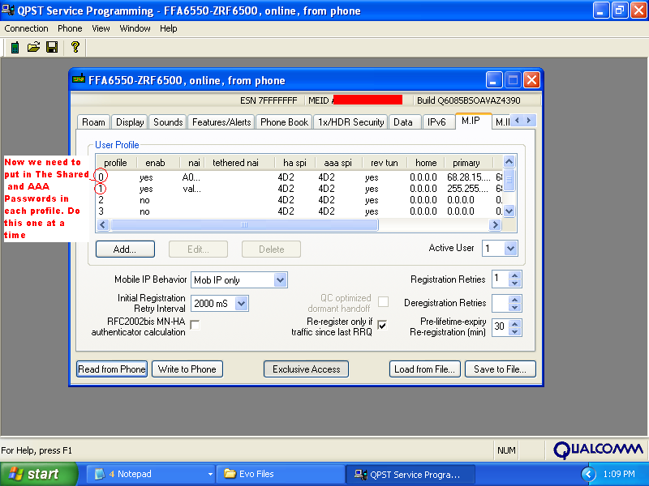**

**Continued...**

**Click profile 0 and click edit. Check and make sure your “NAI” is the correct one for boost mobile. Enter your HA Shared password first, then enter your AAA Password into the text box, next Enter all information that you saved earlier and put them in the required box’s**

**NAI: YOURMEID@hcm.sprintpcs.com**

**Home address: 0.0.0.0**

**Primary HA address: 68.28.15.12**

**Secondary HA address: 68.28.31.12**

**SPI: 4D2**

**SPI: 4D2**

**Rev Tunnel Preferred: Checked now with both passwords hit ok.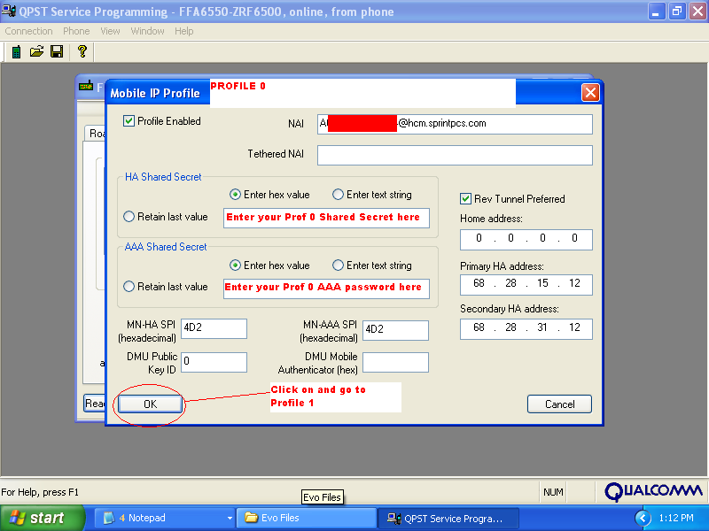**

**Now Profile 1 information below………**

**Enter your HA Shared password first, then enter your AAA Password into the text box, next Enter all information that you saved earlier and put them in the required box’s**

**NAI: YourName@myboostmobile.sprintpcs.com**

**Home address: 0.0.0.0**

**Primary HA address: 255.255.255.255**

**Secondary HA address: 68.28.89.76**

**SPI: 4D2**

**SPI: 4D2**

**Rev Tunnel Preferred: Checked now with both passwords hit ok**

**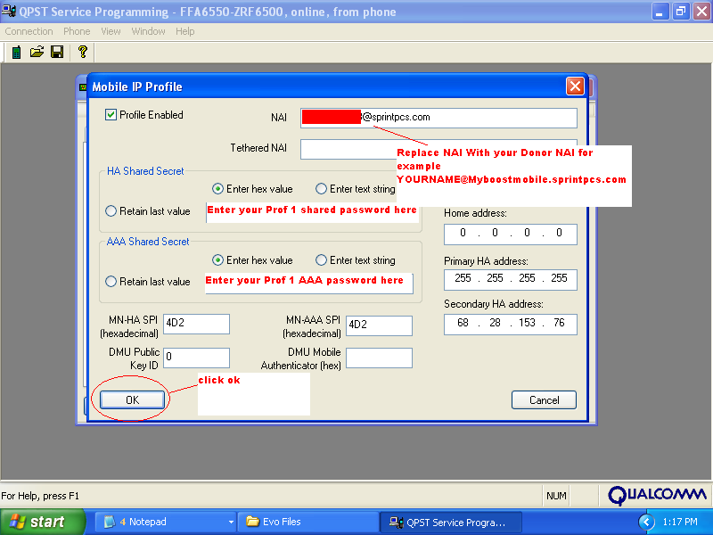**

**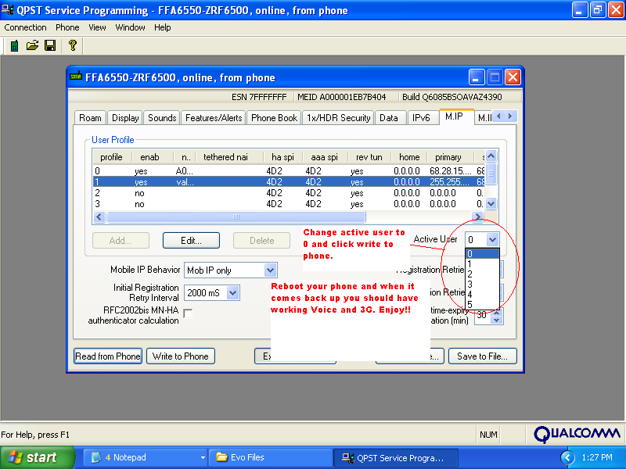**

**Make the active user “0” and Write to phone the Evo will now reboot. When it comes back enjoy 3g. Now for mms dial ##3282#, and enter the SPC code. Tap on advanced and scroll down to you see the URL mms.sprintpcs.com. Change the URL to** [**http://mm.myboostmobile.com**](http://mm.myboostmobile.com)**.**

**Congrats you have now converted your Evo 3D to boost mobile.**

**©2011 APS LIQUIDATION (EBAY NAME TECHJUNKIE)**